Fabric data stores

Introduction
In most of the company they will be using Lakehouse to store their data (in file format and table format). Near the store methode there are also the following that can be used if realy necessary :
- Fabric SQL Database like azure sql database
- KQL database for realtime data
- Warehouse for advanced data analyse (sementic data model) for reporting
Note : Lakehouse stays the most popular one.

Architecture
Data coming from source system will land in the OnLake store and can be set available for all Fabric experiences (data factory , Synapse, data science, PowerBi..)
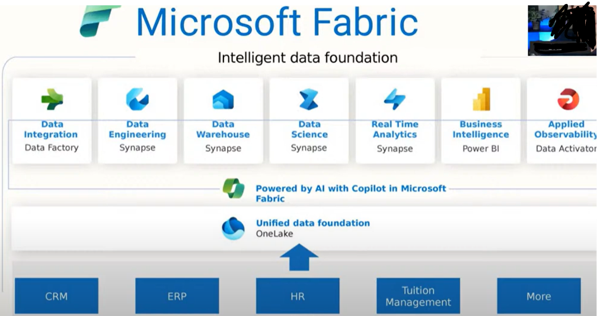

Different Data stores
These are the different store in MS frabric depending on the company data gouvernance strategy:
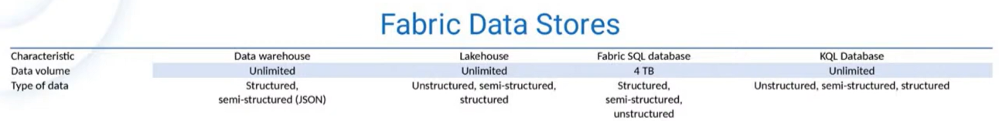
Fabric SQL DB | OLPT (untill 4 T)
KQL Database | Realtime data (unlimited)
Lakehouse | Medaillon architecture
Data warehouse | Semantic model (Star scherma)

Fabric SQL database
Ref: https://www.youtube.com/watch?v=MW6qcdC9K_U
This the fabric version of azure SQL database. Very quick to be created by 1 or 2 click.
One important thing is the cost , forb that check the below info :
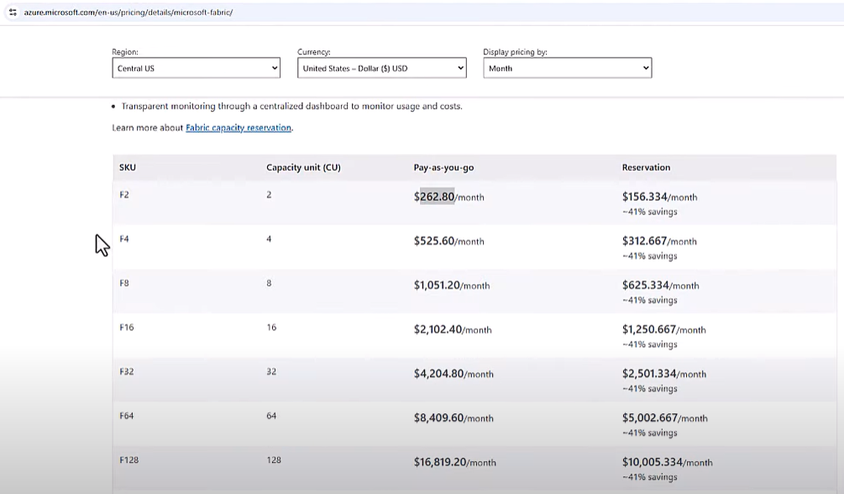

Note: this kind of database can be used to create tables and views as output of given data processing (notebook , dataflows , data pipeline ..)

Fabric KQL database (real time data)
Ref: https://www.youtube.com/watch?v=6QpURM97YXU
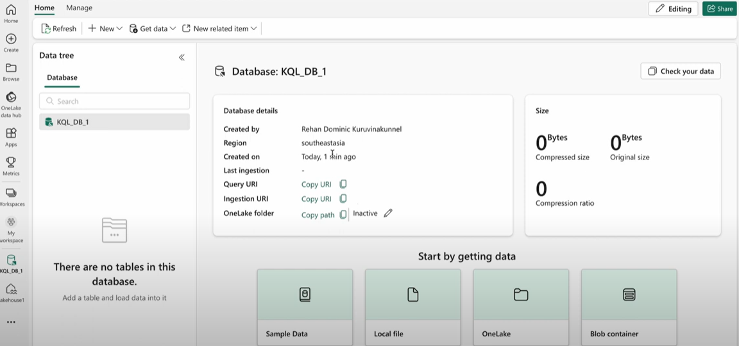

Lakehouse

Definition
Ref: https://www.youtube.com/watch?v=SFta1_70T_U
Lakehouse is a component of the Onlake that help store the data in more structured way for analysis:
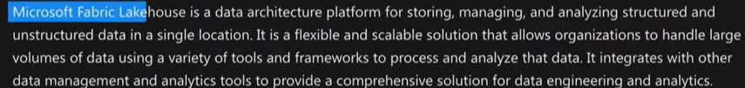

Create

From Synapse Data Engenieering experience , you can create by few click a lake (from a dedicated Worspace)
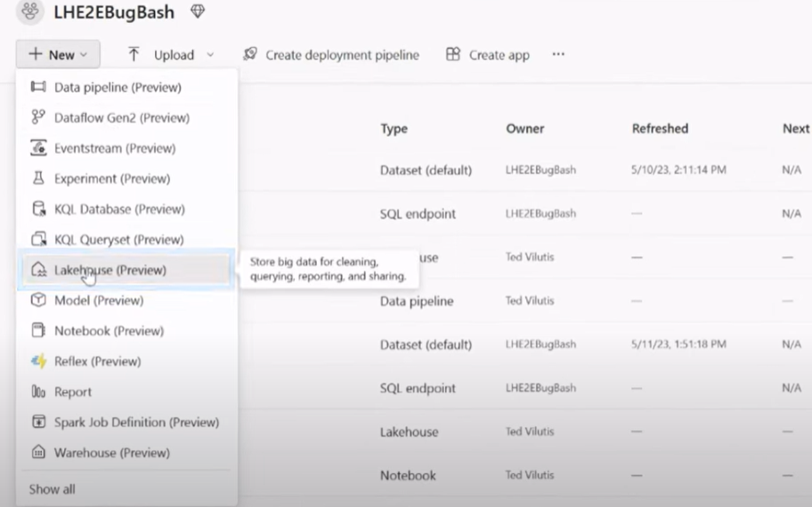
When created, the Lakehouse launched 2 artifacts automatically files and Tables , witch you can use to ingest and organize your data for analysis :
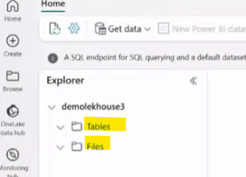

Ingestion
Data flow ingestion using power Query
Data pipeline ingestion using activities
Notebook ingestion using Python, spak
Shortcut referring to an existing file or table in another location like datalake , azure sql ….)
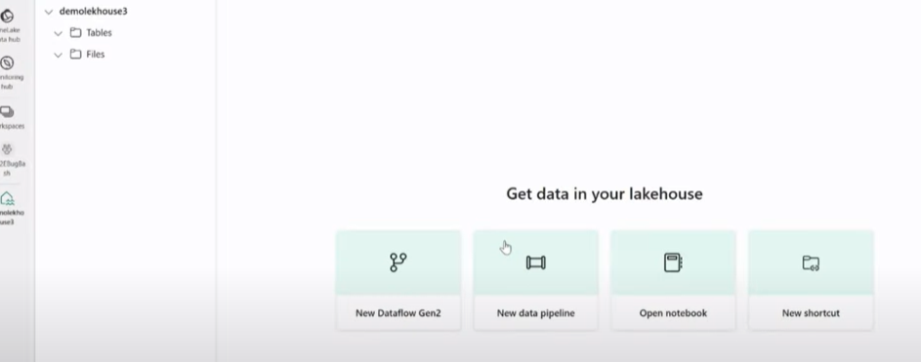

Medaillon architecture
Ref: https://www.youtube.com/watch?v=vK9tDFuhQ6Y&t=1s

Fabric warehouse
Ref: https://www.youtube.com/watch?v=tgQX1yRCWiU
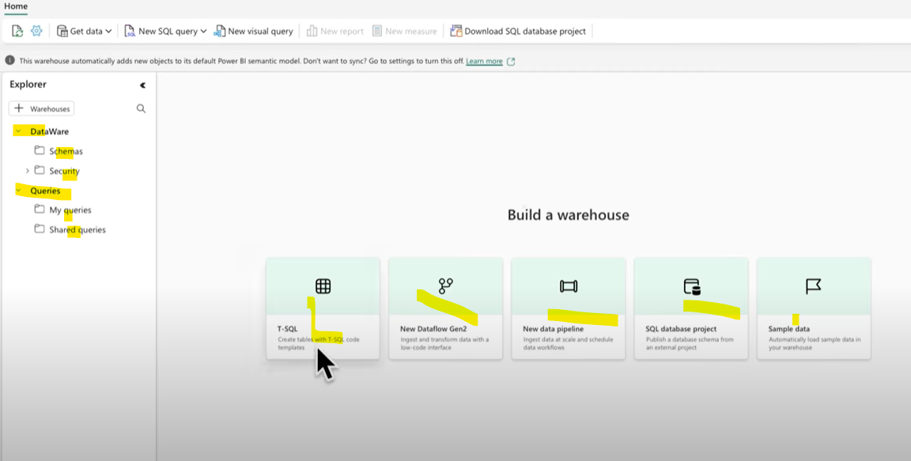
Warehouse and lakehouse have both sql-end point to explore the data in tables.
- Difference is in the lakehouse read-only is allowed using that SQL layer and in the warehouse read and write are allowed.
- In Lake unstructured (Json) , semi-structured (json) and structured data (tabular , parquet) are supported in Lakehouse but not in Warehouse witch allow only structured data (Tables)

Fabric Warehouse vs fabric SQl Database

